
Tripoli Motor Testing Division
223 NC Highway 54 West
Chapel Hill, NC 27514
(919) 357 5681 (c)
March 10, 2018

Gary Rosenfield
RCS Rocket Motor Components, Inc.
2113 West 850 North Street
Cedar City, UT 84721

Dear Mr. Rosenfield,

The Quest Q-Jet A3-4,6FJ single-use motor was tested on February 10, 2018 and March 3, 2018 and is in compliance with NFPA 1125. The motor is certified for hobby rocketry use by the members of the Tripoli Rocketry Association and all approving organizations with reciprocal certifying agreements.

Motor Manufacturer Quest Division, RCS Rocket Motor Components
Manufacturer’s Designation A3-4,6FJ [18mm single use]
Propellant Black Max
TMT Nomenclature 2.5 A3.2

Diameter - 18 mm
Overall Length 3.17” 80.7 mm
Case Length 2.73” 69.4 mm

Loaded Mass .0402 lb 18.21 g
Propellant Mass .0046 lb* 2.1 g*
Burnout Mass .0296 lb 13.44 g

Burn time 0.772 ± .069 sec

Total Impulse 0.562 ± .020 lbf.s 2.500 ± .091 N.s
Max Impulse 1.888 ± .137 lbf 8.398 ± .611 N
Average Impulse 0.729 ± .051 lbf 3.243 ± .225 N
Number of Motors Tested 12
Nominal Measured
Delay Time Data 4 s 4.037, 3.832, 4.015, 4.696, 4.081, 4.464 sec
6 s 5.914, 6.396, 6.179, 6.602, 6.232, 6.215 sec

Casing Temp. [NFPA 1125 7.4.1] Passed

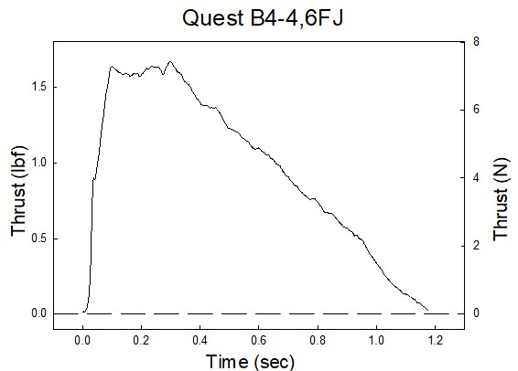

Sincerely,

Alan C. Whitmore
Chair, Tripoli Motor Testing

